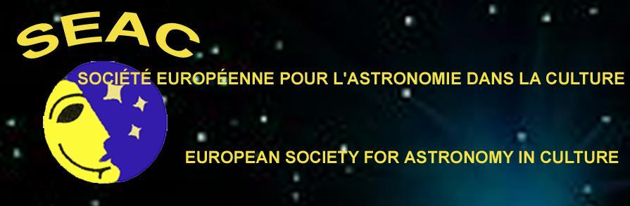
SEAC 2015
Astronomy in Past and Present Cultures

Dear Colleagues,
You will find the final program of SEAC 2015 Conference in the conference web site at the page:
http://www.brera.inaf.it/SEAC2015/program.htm
Many participants had problems in paying the conference fee by bank transfer: because of this reason, WE ACTIVATED THE POSSIBILITY TO PAY BY PAYPAL IN THE CONFERENCE WEB SITE AT THE PAGE:
http://www.brera.inaf.it/SEAC2015/registration.htm
and extended the early booking deadline to JUNE 15th.
We remember that THE EARLY BOOKING RATE (full conference: 280 €, accompanying person: 180 €, students: 100 €) IS VALID ONLY IF ACCOMPANIED BY THE BANK TRANSFER OR PAYPAL PAYMENT RECEIPT.
Please check the Conference website: http://www.brera.inaf.it/SEAC2015 for new information on hotels and tours.

Waiting for you in Rome,
Best regards
Vito Francesco Polcaro
________________________________________________________________
Dott. Ing. V.F. Polcaro
Associated Researcher
Istituto Nazionale di Astrofisica, Istituto di Astrofisica e Planetologia Spaziale - Rome
and
Astronomy and Cultural Heritage Centre, - Ferrara University

Area di Ricerca di Tor Vergata
V. Fosso del Cavaliere 100. I - 00133 Rome - ITALY
phone:+39-347-6685817
e-mail: vitofrancesco.polcaro@iaps.inaf.it

