**Course Information Sheet [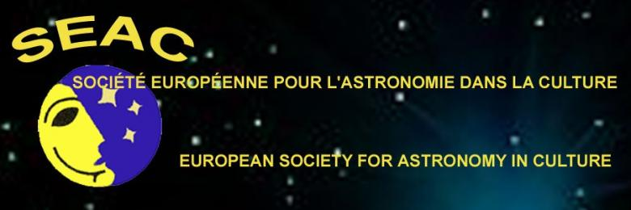](http://www.archeoastronomy.org/content/)**

|  |  |  |  |  |  |  |  |  |  |  |  |  |
| --- | --- | --- | --- | --- | --- | --- | --- | --- | --- | --- | --- | --- |
| Course title: Professional updating course in Cultural Astronomy for high school teachers | | | | | | | | | | | | |
| Contact email:vitofrancesco.polcaro@iaps.inaf.it | | | | | Web page: http://archeo.ara.roma.it/ | | | | | | | |
| Country and Venue: Italy – Civita di Bagnoregio (Viterbo) | | | | | | | | | Fee: none | | | |
| Start date: November 9, 2017 | | | End date: November 11, 2017 | | | | Day(s)/time(s): 3 | | | | | |
| Number of sessions: 6 | | | Hours per session: 4 (+2 h of final discussion) | | | | | | | | Level: MA or MS | |
| Title of qualification to be gained (if any): No specific title; 4 Ministry “credits” for carreer progression | | | | | | | | | | | | |
| Awarding body (if any): Italian Ministry for Education, University and Reseatch (MIUR)) | | | | | | | | | | | | |
| Essential materials: A purposely produced booklet + DVD with the lessons | | | | | | | | | | | | |
|  | | | | | | | | | | | | |
| **Course aims** (Max. 20 words)**:** Make high school teachers able to introduce cultural astronomy topics in their STEM or human sciences lessons | | | | | | | | | | | | |
|  | | | | | | | | | | | | |
| **Course description** (Max. 30 words)**:**  Full time, residential course**,** fully supported by the local Municipality, recognized by MIUR  16h of front lesson;  4h of archeoastronomical field activity;  2h for discussing the results of practical exercises. | | | | | | | | | | | | |
|  | | | | | | | | | | | | |
| **Any prior knowledge or entry requirements?** MA or MS (5 years) + school teaching expertise | | | | | | | | | | | | |
|  | | | | | | | | | | | | |
| **Course content: what topics will the course cover?** (Max. 100 words)  Positional astronomy  History of Western Astronomy from the beginning to Rennaicence;  Modern astronomy from Galileo to present epoch;  History of Chinese astronomy from the beginning to the 17th century  Archaeoastronomy as a subsidiary science of archeology  Methods for the study of cultural heritage with astronomical value  Retrieval of astrophysical data from ancient documents  Ethnoastronomy | | | | | | | | | | | | |
|  | | | | | | | | | | | | |
| **Teaching, learning and assessment methods:** *tick those to be used ✓* | | | | | | | | | | | | |
| Distance Learning |  | Discussion | | X | | Group work | | X | | Individual work | | X |
| Project work |  | Research | |  | | Role play | |  | | Written work | |  |
| Question and answer | X | Activity outside class time | | X | | Observation | | X | | Practical work | | X |
| Presentation | X | Field trip | | X | | Other (state) | | | | | | |
|  | | | | | | | | | | | | |
| **How will I receive feedback on my learning progress and achievement?** (Max. 30 words)  From the final discussion and evaluation of execises | | | | | | | | | | | | |
|  | | | | | | | | | | | | |
| **Learning outcomes. By the end of the course, students should be able to:** | | | | | | | | | | | | |
| * Teach the basis of cultural astronomy to high schools students | | | | | | | | | | | | |
|  | | | | | | | | | | | | |
| **Reading and information sources** (Max. four references)**:**  **Schaefer B. E., 2006,:** *Case Study of Three of the Most Famous Claimed Archaeoastronomical Alignements in North America* in,*Viewing the Sky Through Past and Present Cultures, Oxford VII International Conferences on Archaeoastronomy* (Bostwick, T.W. & Bates, B. eds) Phoenix (AZ) (Pueblo Grande Museum Anthropological Papers **15**), 71-77.  **Incerti M., Bònoli F., Polcaro V.F**.; 2010, *Transient astronomical events as inspiration sources of Medieval and Renaissance art.i*, in “Astronomy and Power – How Worlds are structured”, International Conference on Archaeoastronomy and Ethnoastronomy, Société Européenne pour l’Astronomie dans la Culture, SEAC 2010, Gilching (Germany), Aug.30-Sep.4 2010  **Polcaro V. F. Polcaro A.**, 2009, *Man and Sky: Problems and Methods of Archaeoastronomy*,  Archeologia e Calcolatori, 20, 223-245  **Vitagliano, A.**, *SOLEX 11.0 User Manual and Technical Notes*, http://chemistry.unina.it/~alvitagl/solex/, 2010 | | | | | | | | | | | | |
|  | | | | | | | | | | | | |
| **Suggestions for progression to further study or for using the skills and knowledge gained:**  Seminars (for students and teachers) will be held in the high schools where the participants teach. | | | | | | | | | | | | |
|  | | | | | | | | | | | | |
| **Please indicate recent past or anticipated number of enrolments on this course:** 20 (close number course) | | | | | | | | | | | | |